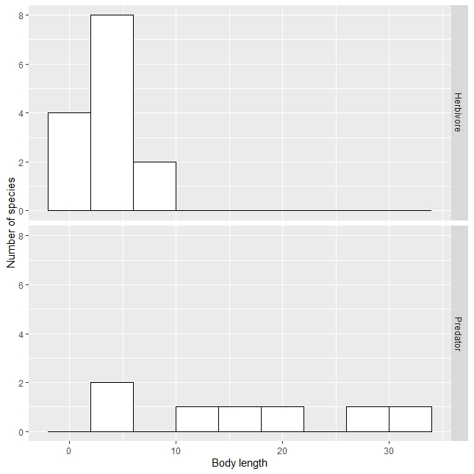
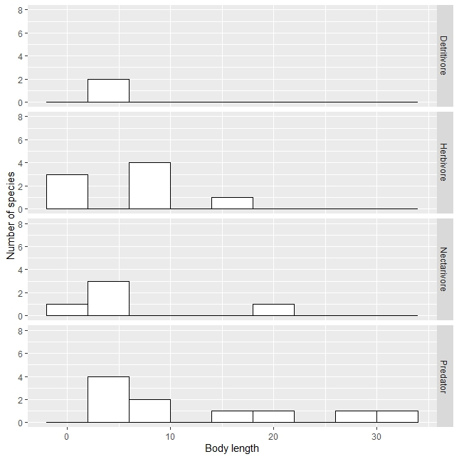
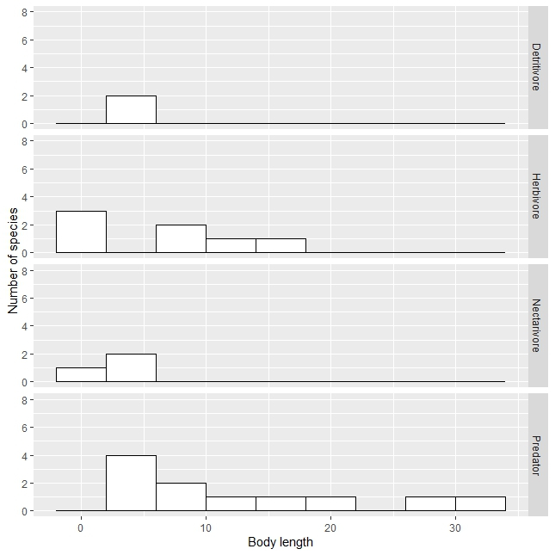
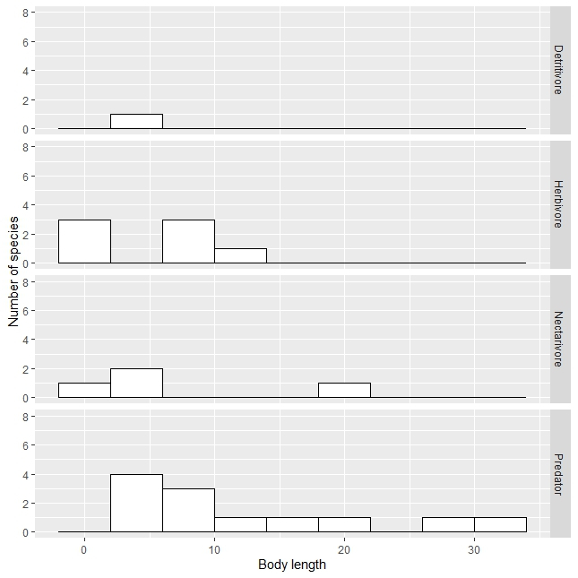
A
B
C
D
Figure S1. Body length of beetle species per feeding group in A: pine, B: new recovering fynbos, C: old recovering fynbos and D: fynbos

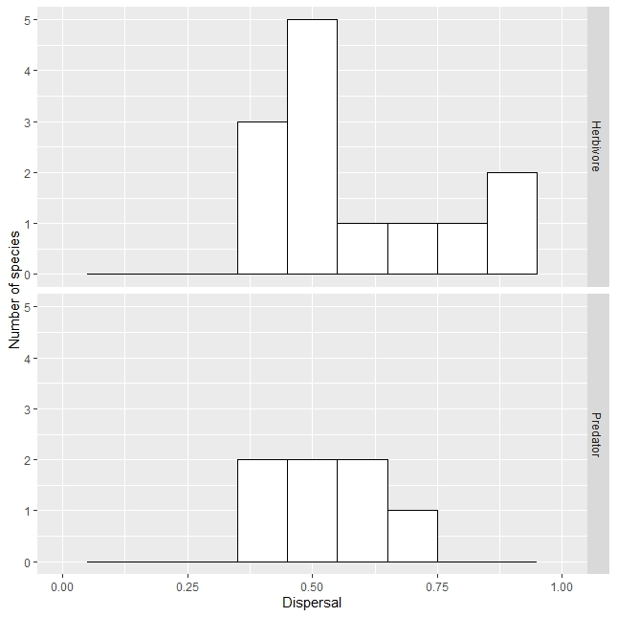
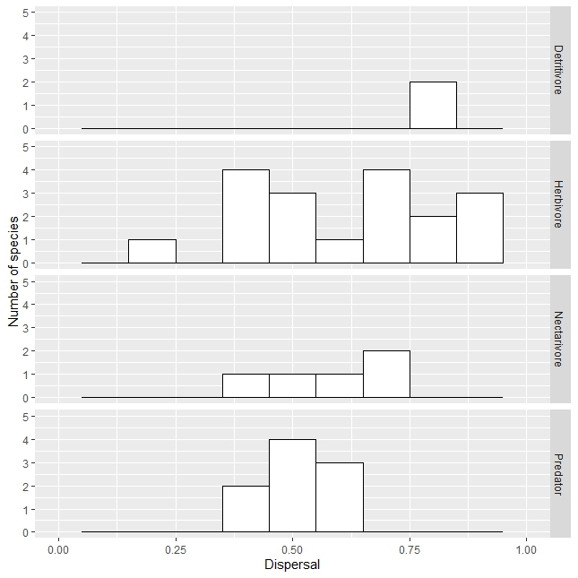
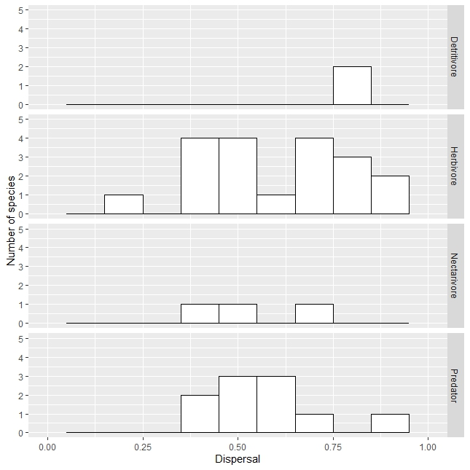
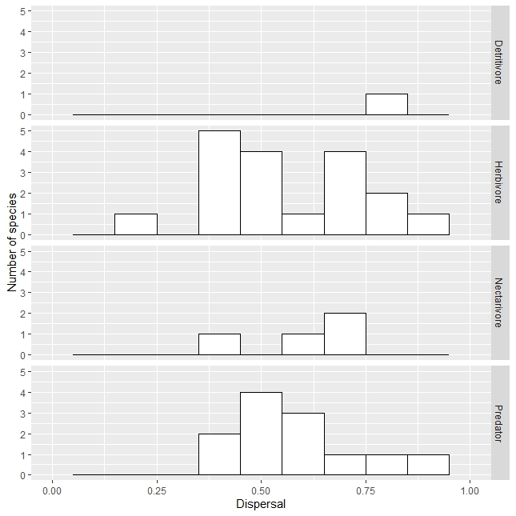
A
B
C
D
Figure S2. Dispersal of beetle species in A: pine, B: new recovering fynbos, C: old recovering fynbos and D: fynbos

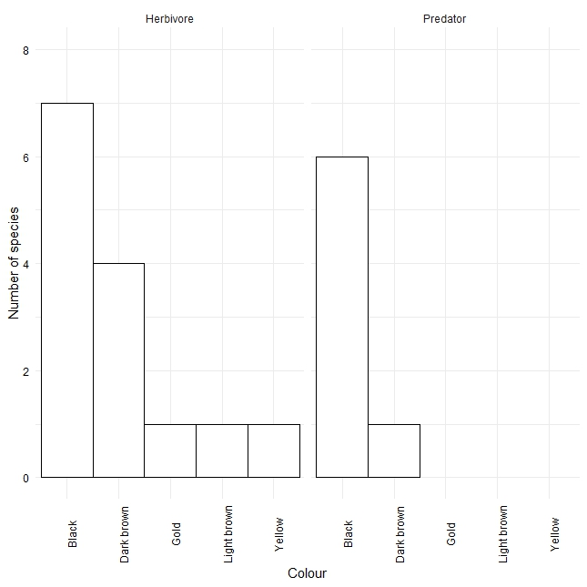
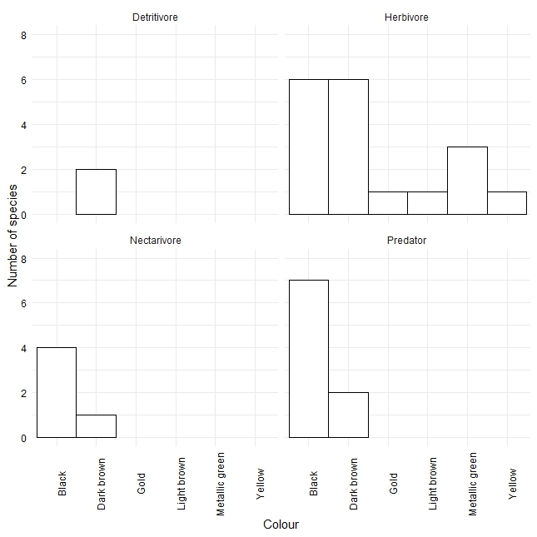
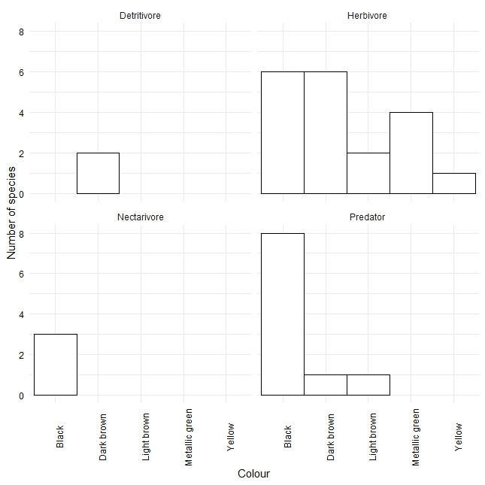
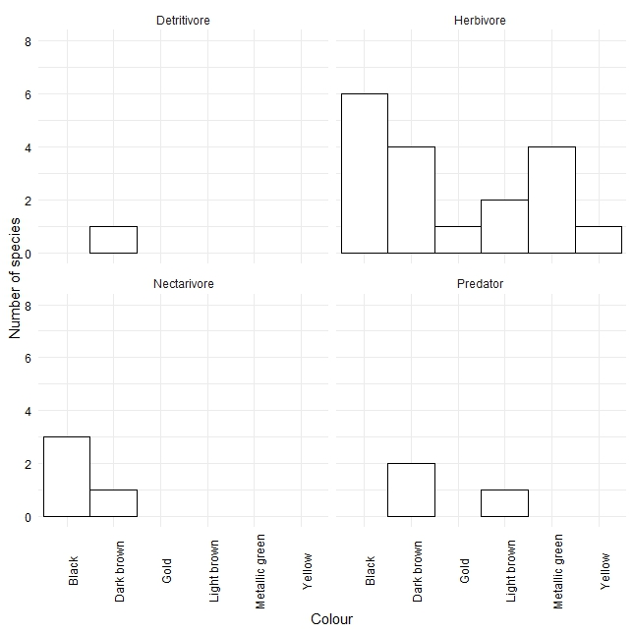
Figure S3. Colour of beetle species in A: pine, B: new recovering fynbos, C: old recovering fynbos and D: fynbos
A
B
C
D

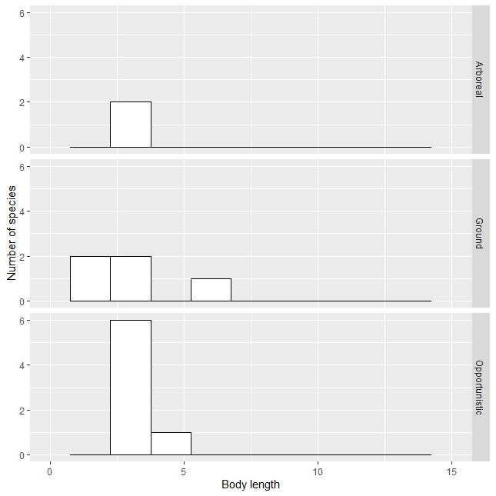
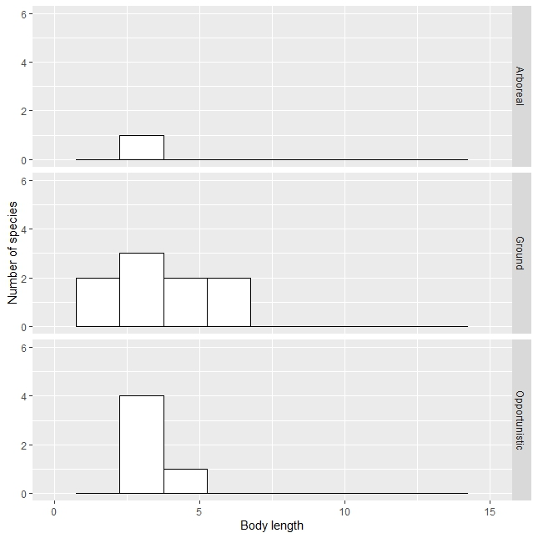
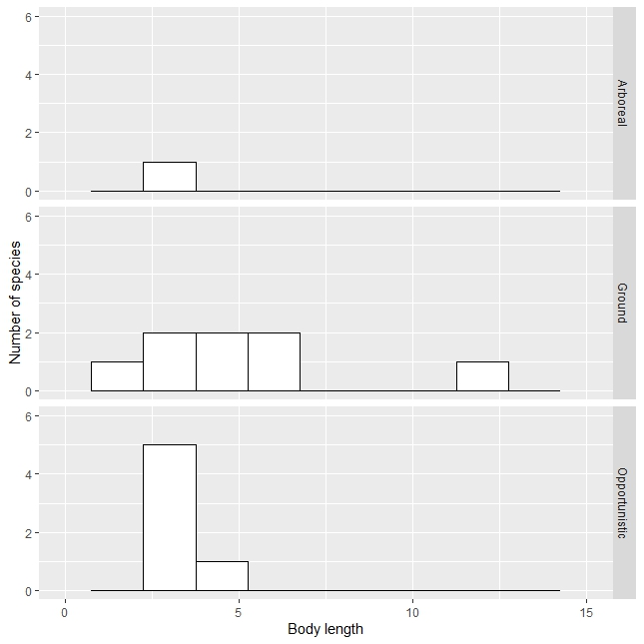
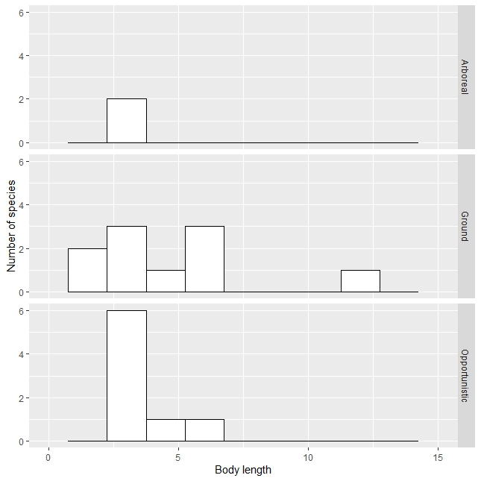
A
B
C
D
Figure S4. Body length of ant species per nesting type in A: pine, B: new recovering fynbos, C: old recovering fynbos and D: fynbos

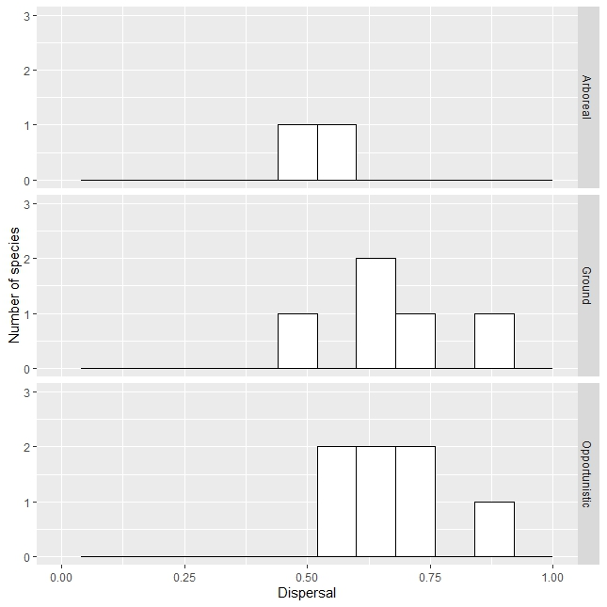
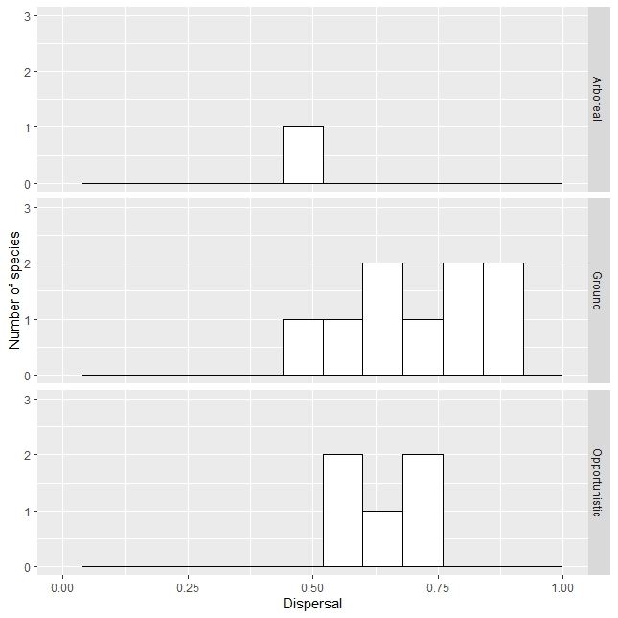
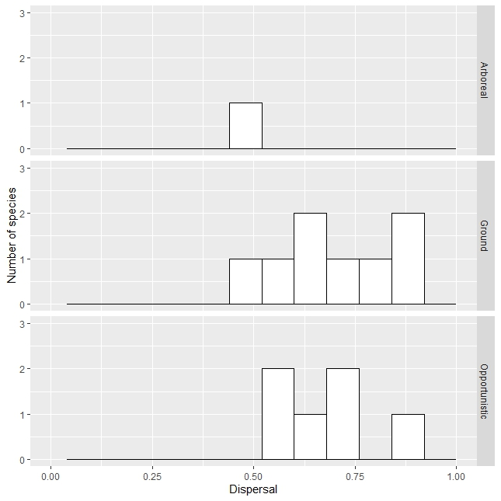
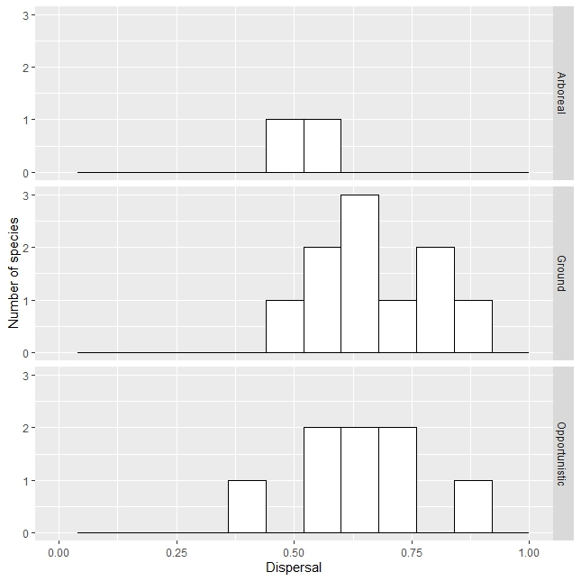
A
B
C
D
Figure S5. Dispersal of ant species per nesting type in A: pine, B: new recovering, C: old recovering and D: fynbos

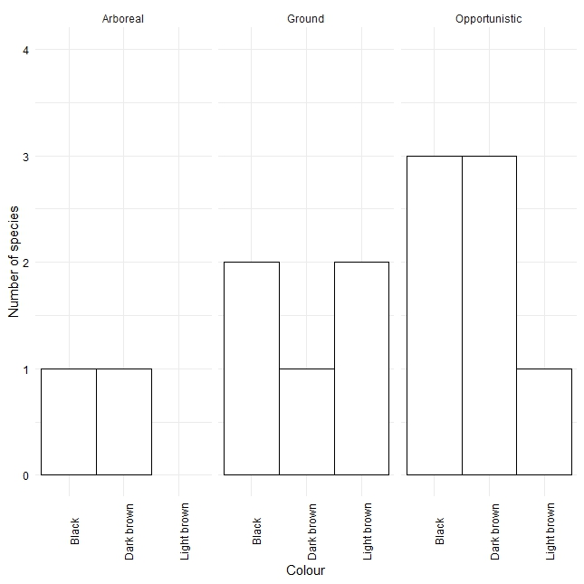
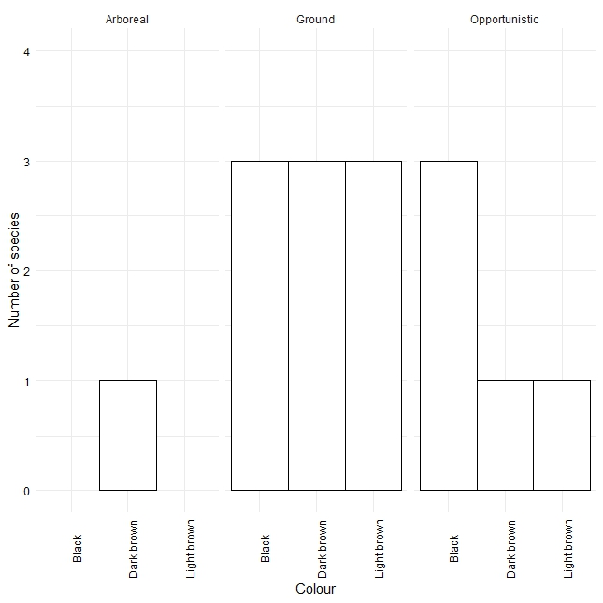
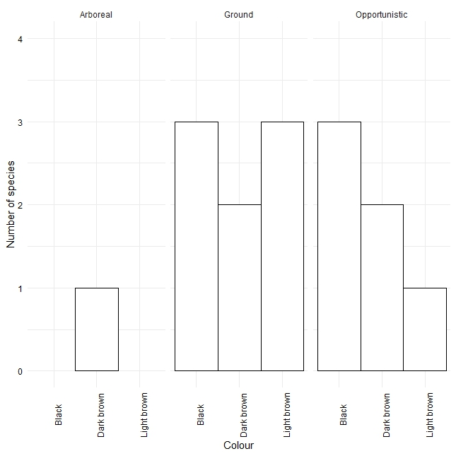
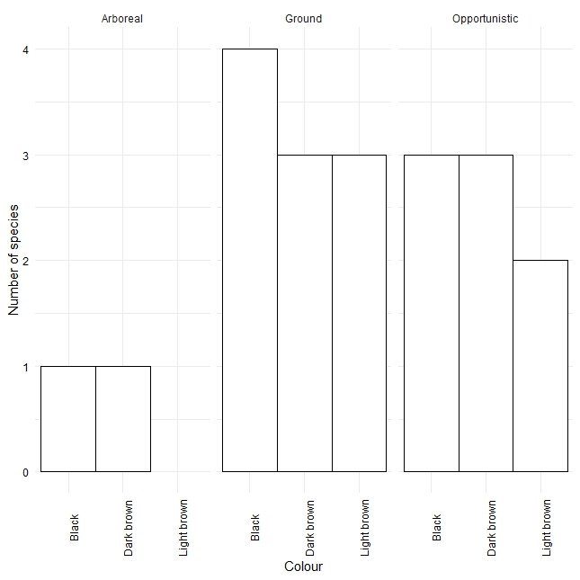
Figure S6 Colour of ant species in A: pine, B: new recovering, C: old recovering and D: fynbos
A
B
C
D
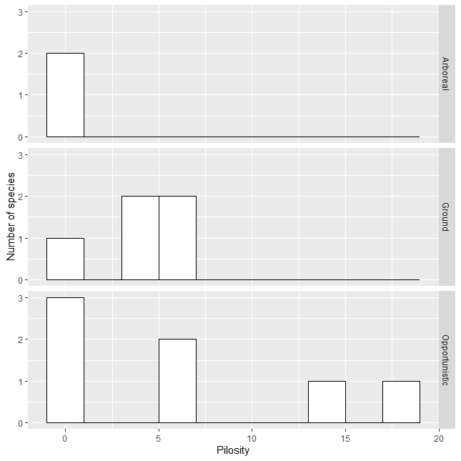
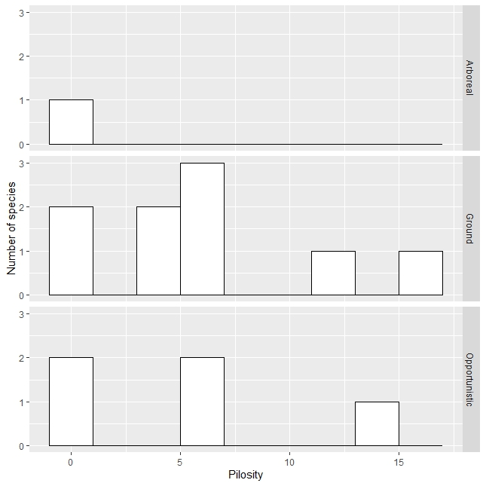
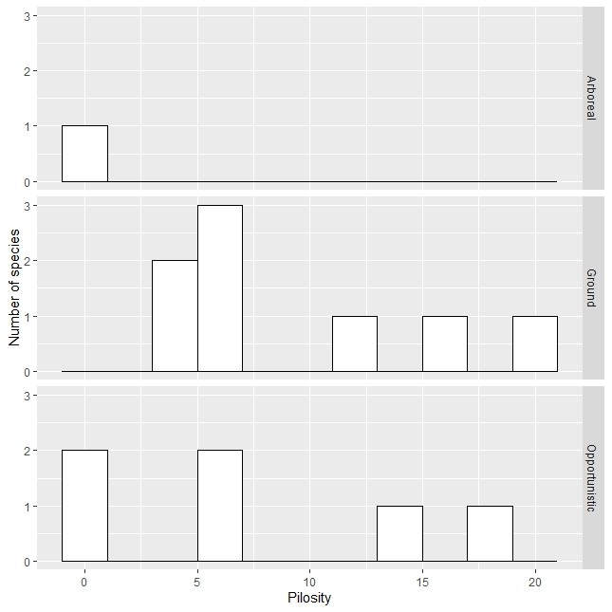
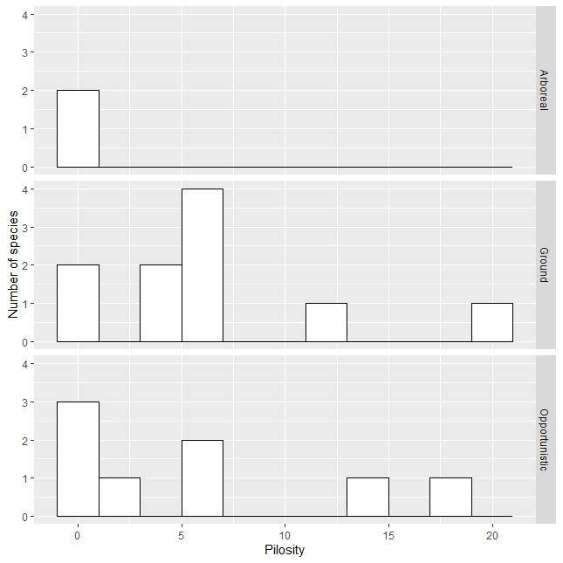
A
B
C
D
Figure S7. Pilosity of ant species per nesting type in A: pine, B: new recovering fynbos, C: old recovering fynbos and D: fynbos

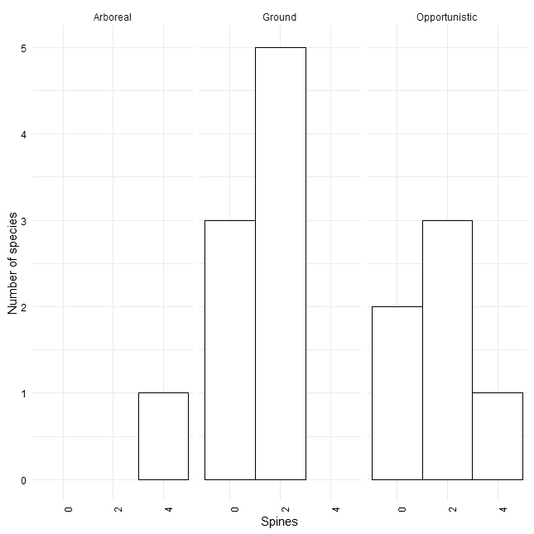
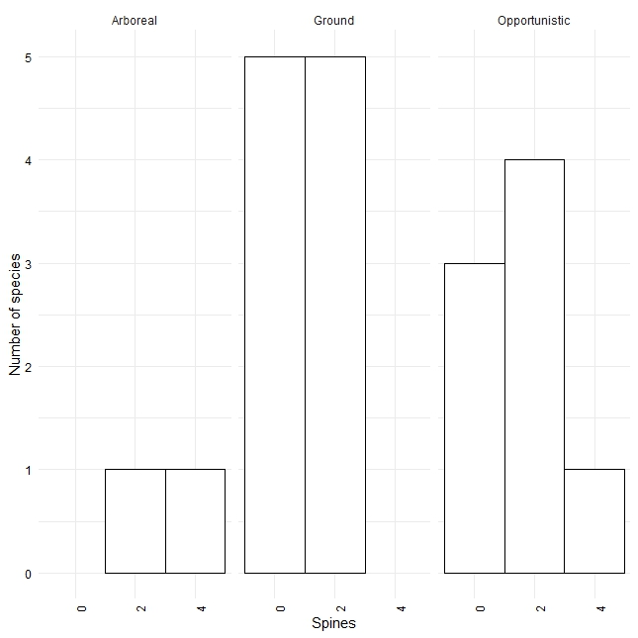
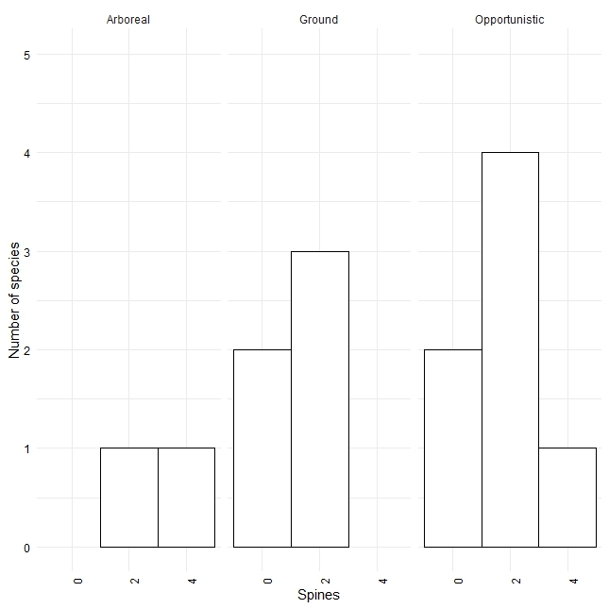
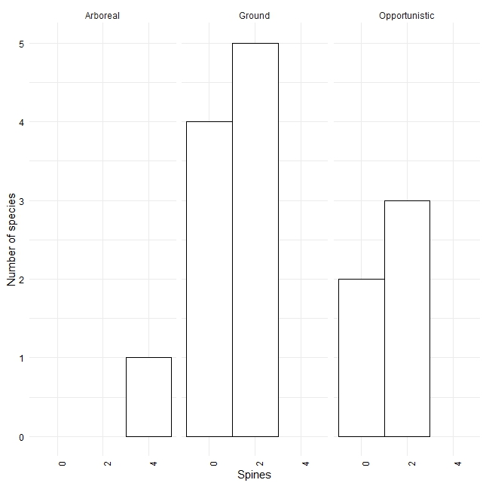
C
D
A
B
Figure S8. Number of spines in ant species per nesting type in A: pine, B: new recovering fynbos, C: old recovering fynbos and D: fynbos
Table S1. Beetle morphospecies codes and the corresponding species traits.
Spp code | Family | Feeding guild | Body length (mm) | Dispersal | Colour
Col003 | Mordellidae | Nectarivore | 4.482 | 0.352 | Black
Col004 | Scarabaeidae | Herbivore | 9.85 | 0.507 | Dark brown
Col005 | Melyridae | Herbivore | 5.387 | 0.247 | Metallic green
Col007 | Chrysomelidae | Herbivore | 2.005 | 0.4 | Light brown
Col008 | Staphylinidae | Predator | 3.292 | 0.475 | Dark brown
Col009 | Carabidae | Predator | 30.671 | 0.387 | Black
Col010 | Carabidae | Predator | 16.932 | 0.586 | Black
Col012 | Carabidae | Predator | 12.009 | 0.706 | Black
Col013 | Curculionidae | Herbivore | 5.153 | 0.528 | Dark brown
Col015 | Staphylinidae | Predator | 28.065 | 0.445 | Black
Col018 | Chrysomelidae | Herbivore | 2.206 | 0.423 | Black
Col023 | Scarabaeidae | Detritivore | 2.381 | 0.757 | Dark brown
Col027 | Carabidae | Predator | 18.846 | 0.545 | Black
Col029 | Scarabaeidae | Detritivore | 4.289 | 0.838 | Dark brown
Col030 | Curculionidae | Herbivore | 2.107 | 0.733 | Dark brown
Col041 | Carabidae | Predator | 3.261 | 0.623 | Black
Col042 | Chrysomelidae | Herbivore | 1.764 | 0.417 | Black
Col050 | Scarabaeidae | Herbivore | 15.892 | 0.726 | Dark brown
Col054 | Chrysomelidae | Herbivore | 2.015 | 0.866 | Light brown
Col060 | Curculionidae | Herbivore | 1.566 | 0.508 | Black
Col066 | Curculionidae | Herbivore | 5.992 | 0.844 | Black
Col068 | Chrysomelidae | Herbivore | 1.376 | 0.462 | Black
Col074 | Chrysomelidae | Herbivore | 1.838 | 0.375 | Black
Col093 | Chrysomelidae | Herbivore | 4.667 | 0.662 | Gold
Col094 | Mordellidae | Nectivore | 3.603 | 0.463 | Black
Col098 | Chrysomelidae | Herbivore | 4.519 | 0.482 | Yellow
Col101 | Melyridae | Herbivore | 9.408 | 0.378 | Dark brown
Col104 | Tenebrionidae | Predator | 6.264 | 0.51 | Dark brown
Col106 | Mordellidae | Nectarivore | 1.96 | 0.673 | Black
Col108 | Scarabaeidae | Herbivore | 5.992 | 0.808 | Dark brown
Col109 | Meloidae | Herbivore | 13.396 | 0.707 | Metallic green
Col115 | Chrysomelidae | Herbivore | 6.481 | 0.68 | Metallic green
Col116 | Scarabaeidae | Nectivore | 19.726 | 0.75 | Dark brown
Col119 | Chrysomelidae | Herbivore | 4.262 | 0.803 | Metallic green
Col123 | Carabidae | Predator | 15.71 | 0.783 | Black
Col130 | Melyridae | Herbivore | 6.535 | 0.352 | Black
Col132 | Carabidae | Predator | 9.052 | 0.539 | Black
Col133 | Carabidae | Predator | 4.862 | 0.6 | Black
Col136 | Carabidae | Predator | 8.934 | 0.856 | Light brown
Col137 | Chrysomelidae | Herbivore | 2.855 | 0.583 | Black
Col142 | Scarabaeidae | Detritivore | 4.125 | 0.772 | Dark brown
Col154 | Curculionidae | Herbivore | 5.362 | 0.889 | Black
Col172 | Scarabaeidae | Herbivore | 5.248 | 0.915 | Dark brown
Col176 | Curculionidae | Herbivore | 4.449 | 0.649 | Black
Col178 | Dermestidae | Nectarivore | 2.322 | 0.57 | Black

Table S2. Ant species codes and their corresponding trait values
Spp Code | Scientific Name | Body length (mm) | Dispersal | Colour | Nesting type | No. of spines | Pilosity | Sculpturing
For003 | Lepisiota capensis | 2.675 | 0.758 | Black | Ground | 2 | 6 | 2
For006 | Monomorium tablense | 1.802 | 0.497 | Light brown | Ground | 2 | 5 | 1
For008 | Camponotus werthi | 2.447 | 0.714 | Black | Opportunistic | 2 | 7 | 1
For009 | Crematogaster capensis | 3.226 | 0.46 | Dark brown | Arboreal | 4 | 0 | 2
For011 | Tetramorium | 3.615 | 0.635 | Light brown | Opportunistic | 2 | 6 | 1
For015 | Tetramorium sericeiventre | 2.824 | 0.647 | Dark brown | Opportunistic | 2 | 0 | 2
For016 | Crematogaster delagoensis | 3.608 | 0.524 | Black | Arboreal | 2 | 0 | 2
For017 | Technomyrmex pallipes | 2.865 | 0.597 | Black | Opportunistic | 0 | 0 | 2
For018 | Technomyrmex | 2.907 | 0.582 | Dark brown | Opportunistic | 0 | 0 | 2
For019 | Camponotus bianconii | 6.041 | 0.863 | Dark brown | Ground | 0 | 4 | 1
For021 | Monomorium boerorum | 2.015 | 0.668 | Black | Ground | 0 | 0 | 1
For024 | Tetramorium capense | 3.136 | 0.878 | Dark brown | Opportunistic | 4 | 18 | 2
For026 | Myrmicaria nigra | 6.341 | 0.768 | Black | Ground | 2 | 12 | 2
For027 | Monomorium havilandi | 3.08 | 0.835 | Dark brown | Ground | 0 | 0 | 1
For030 | Pheidole tenuinodis | 2.839 | 0.671 | Light brown | Ground | 2 | 6 | 2
For033 | Pheidole caffra | 4.576 | 0.587 | Light brown | Ground | 2 | 7 | 1
For035 | Tetramorium grassii | 4.146 | 0.721 | Black | Opportunistic | 2 | 15 | 2
For036 | Bothroponera cavernosa | 12.171 | 0.624 | Black | Ground | 0 | 20 | 2
For037 | Messor denticornis | 5.036 | 0.845 | Dark brown | Ground | 0 | 16 | 1
For042 | Leptogenys castanea | 6.021 | 0.382 | Light brown | Opportunistic | 0 | 2 | 1
For048 | Camponotus sp. | 6.21 | 0.556 | Dark brown | Ground | 0 | 6 | 1

